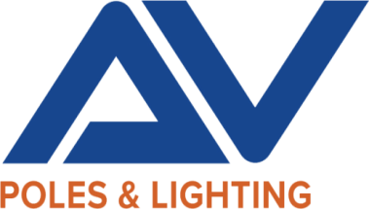

43827 Division Street
Lancaster, CA 93535-4061

01/28/2025

RE:

Attn:

To Whom It May Concern,

This letter serves as confirmation that AV Poles & Lighting manufactures steel and aluminum poles, brackets, and exterior lighting fixtures in our facility located in Lancaster, California, U.S.A. Our products meet the domestic content requirements set forth by the Buy American Act (BAA) (41 U.S.C. §§ 8301–8305) and the Build America, Buy America Act (BABA) (Public Law No: 117-58, Section 70901).

In addition, our products comply with Buy America provisions under 49 C.F.R. Part 661, as applicable, ensuring compliance with federal procurement guidelines for infrastructure and transportation projects.

Sincerely,

Matthew F. Uhre

Matthew Uhre
AV Poles and Lighting
844-770-AVPL

